**a**

**MINI PORJECt REPORT**

**ON**

**“Online Raddiwala”**

FOR PARTIAL FULFILLMENT

OF THE REQUIREMENTS FOR THE

**PROJECT BASED LEARNING**

oF S.E. E&TC – 2019 Course, SPPU, Pune

By

**Kad Sakshi Dipak 22425**

**Mirajkar Pratik Pramod 22437**

**Misal Vedant Ullhas 22439**

**GUIDE**

**Prof. C. C. Pawar**



**Department Of**

**Electronics and TELECommunication ENGINEERING**

**PUNE INSTITUTE OF COMPUTER TECHNOLOGY**

**PUNE – 43**

**ACADEMIC YEAR: 2020 - 2021**

**Department of Electronics and Telecommunication Engineering**

**Pune Institute of Computer Technology, Pune – 43**

**CERTIFICATE**

This is to certify that the Mini Project Report entitled

**Online Raddiwala**

has been successfully completed by

Kad Sakshi Dipak 22425

Mirajkar Pratik Pramod 22437

Misal Vedant Ullhas 22439

Is a bona fide work carried out by them under the supervision of Mr. Chetan Pawar and it is approved for the partial fulfillment of the requirements for the Project based learning of S.E. E&TC – 2021 Course of the Savitribai Phule Pune University, Pune.

Prof. Chetan Pawar Dr. Sandeep Gaikwad Dr. R. Sreemathy

(Project Guide) (HOD) (Principal)

**Date:**

**Place: PICT, PUNE**

**ACKNOWLEDGEMENT**

It takes immense pleasure in completing and submitting the final project report.

I would like to express my gratitude to our respected **PRINCIPAL Dr. R. Sreemathy , HOD Dr. Sandeep Gaikwad** and **PROF. Chetan Pawar** my project guide for their continuous encouragement, valuable guidance and the help for completing the project work.

Last but not the least, I am thankful to all the college staff, friends and family for helping me directly or indirectly in my project.

Kad Sakshi Dipak

Mirajkar Pratik Pramod

Misal Vedant Ullhas

**Date:**

**Place: PICT, PUNE**

**ABSTRACT**

Improper management of waste is major problem in front of urbanization. Therefore, we have developed a webpage cum working system which will ensure better waste management and connection among society and servants by providing online approach to them.

The project ‘Online Raddiwala’ is a web-based application. This website provides facility for door to door online selling of paper waste. This system allows user to sign up and send a pickup request to sell their paper waste. We purchase all kind of papers waste like newspaper, copies, old books, cartons, magazines, etc. We make use of technology in whole process of collecting waste.

We have introduced the use of electronic weighing scales at the doorsteps of clients. Our first priority of waste collector is customer satisfaction which we try to achieve by giving the best price, accurate weight (Electronic Weighting Machine)

The webpage will collect simple information from users like mobile number, address and suitable time at which scrap can be collected. It will also provide facilities to the user such as scheduling-rescheduling of request, cancellation of request and standardized price list. For the development of webpage, operations like scripting, documentation are performed using CSS, Bootstrap, HTML, etc. Databases like MySQL, package managers and PHP are used in the backend for fundamental working and coordination.

**INDEX**

|  |  |  |
| --- | --- | --- |
| Introduction | | |
| 1.1 | | Back ground and Context |
| 1.2 | | Relevance |
| 1.3 | | Literature Survey |
| 1.4 | | Motivation |
| 1.5 | | Aim of the Project |
| 1.6 | | Scope and Objectives |
| System Design | | |
| 2.1 | | Technical Approach |
| 2.2 | | Hardware / software resources |
| 2.3 | | Block diagram |
| 2.4 | | Flow chart Diagram |
| 2.5 | | Use case diagram |
| 2.6 | | Class diagram |
| 2.7 | | Component Diagram |
| User Interface Design | | |
| 3.1 | Home Page | |
| 3.2 | User Login | |
| 3.3 | User Registration | |
| 3.4 | Pickup Request | |
| 3.5 | User Profile | |
| 3.6 | User Feedback | |
| 3.7 | Services | |
| 3.8 | Rate card | |
| Testing | | |
| 4.1 | Testing and debugging | |
| Results and conclusion | | |
| 5.1 | Advantages and Disadvantages | |
| 5.2 | Limitations | |
| 5.3 | Conclusion | |
| 5.4 | Future scope | |
| References | | |

**CHAPTER 1:**

**INTRODUCTION**

* 1. **BACKGROUND AND CONTEXT**

The project which is proposed by us deals with the regular paper waste or in local language we call it “Raddi”. Our project is indirectly a part of solid waste management initiative. Solid waste refers to everything that goes out in trash. Municipal solid waste are wastes from house, stores, offices, schools, hospitals, etc., that are collected and disposed through by the municipality. The municipal solid waste generally comprises paper, food waste, plastic, glass, metals, rubber, leather, textile etc.

Burning reduces the volume of the waste, although it is generally not burnt to completion and cause air pollution and open dumps in local areas often serve as breeding ground for rats and flies. One of the best solutions for this problem is to collect that waste form houses and try to recycle it as much as possible. Our project of selling raddi online is dealing with paper waste management.

**A] SURVEY:**

Online research and group interviews were taken by our team about 2-3 weeks for discussing the various problems they faced regarding offline or online paper waste collection and their solutions and suggestions for the same.

**B] PROJECT ELABORATION:**

The first prototype of online raddi selling would be able to accept pickup request from user for his paper waste. User will be able to get information about various charges according to the types of paper waste. The system will allow user to register himself and create his profile which includes user name, phone number, email and address which can be updated any time user want. It will also provide date and time facility for pickup request according to user wish. After confirming request, the pickup boy will arrive at given time and date to user’s house with electronic weighing machine. Amount in exchange of paper waste will be paid in cash or online mode(using GPay, Paytm etc.)

* 1. **RELEVANCE**

We intend to help out busy people to collect their recyclables by offering free pickup service. We work as a ‘Recyclable Material Collector’ by offering doorstep collection service for individual houses, societies, organizations and industries. Initially we started our services by collecting the old newspapers, milk packets and plastic bottles by raising awareness about the importance of recycling. We collect the recyclable material from consumer then send to respective manufacturing plant to make the new products. We offer free pickup service, accurate weight and right value for the recyclable materials with complimentary gift conveying social message to plant the trees and save the environment. It’s simple to being eco-friendly; give your recyclables old newspapers, milk packets and plastic bottles in a most environment friendly manner. We invite you to join our hands and try to help us in recycling management.

* 1. **LITERATURE SURVEY**
* **Sources of information collection**

Following are various types of survey techniques used:

* **Primary Information:**

Primary information was collected through interviews with the people and the servant with the sample size of 10-15 people on random selection basis method.

* **Secondary Information:**

The secondary information and theory was collected form internet, daily newspaper, official website similar to our project topic

* **Other methods:**

More of the data was impossible due to time, less team members and other constraints to involve the entire population or universe of study. I have used the methods for collecting the primary information as follows:

* **Observation Method**
* **Questionnaire**
  1. **MOTIVATION**
* **Environment Factor:**

The need to reduce our garbage generation should be a prime goal, instead, we are increasing the use of paper waste product and throwing it in open dumps after using them which is very harmful for our environment. Instead of throwing, if we are recycling this waste it will be a great help for waste management process. Recycling will again help to save many trees lives.

* **Time factor:**

Everyone is busy in their life now days and don’t have time to wait or visit any paper waste purchaser to sell their waste. So one of the motivation behind this project is to save the user time by providing him online pickup request facility according to his schedule.

* 1. **AIM OF PROJECT**
* To build and provide online web platform for online selling of paper waste.
  1. **SCOPE AND OBJECTIVES**

**A] Scope:**

We face many difficulties when we have to sell scrap or paper waste but this website will solve this problem. We don’t have to wait for waste collector any more. It’s a digital world so this application provides digital way to sell our paper waste.

**B] Objectives:**

* Save and reduce waiting time of user who wants to sell their paper waste.
* Earn money through paper waste selling.
* Provide convenient time facility for pickup request to user.
* Minimize open dumping garbage.
* Save trees by recycling paper waste.

**CHAPTER 2:**

**SYSTEM DESIGN**

**2.1 TECHNICAL APPROACH**

To put up those ideas in front you require a platform, here which we used is web page development. It has two parts mainly as **[1] Front-End & [2] Back-End**. This requires several tools which are we going to discuss as follows:

**[A] FRONT-END**

**1. HTML (TEMPLATE)**

* **Hypertext Mark-up Language** (**HTML**) is the standard mark-up language for documents designed to be displayed in a web browser.
* It can be assisted by technologies such as Cascading Style Sheets (CSS) and scripting languages such as JavaScript.
* Web browsers receive HTML documents from a [web server](https://en.wikipedia.org/wiki/Web_server) or from local storage and [render](https://en.wikipedia.org/wiki/Browser_engine) the documents into multimedia web pages.
* [HTML elements](https://en.wikipedia.org/wiki/HTML_element) are the building blocks of HTML pages. With HTML constructs, [images](https://en.wikipedia.org/wiki/HTML_element#Images_and_objects) and other objects such as [interactive forms](https://en.wikipedia.org/wiki/Fieldset) may be embedded into the rendered page.
* for HTML provides a means to create [structured documents](https://en.wikipedia.org/wiki/Structured_document) by denoting structural [semantics](https://en.wikipedia.org/wiki/Semantics) text such as headings, paragraphs, lists, [links,](https://en.wikipedia.org/wiki/Hyperlink) quotes and other items.
* HTML elements are delineated by tags, written using [angle brackets.](https://en.wikipedia.org/wiki/Bracket#Angle_brackets) Browsers do not display the HTML tags, but use them to interpret the content of the page.

1. **BOOTSTRAP (FOR LAYOUTS)**

* **Bootstrap** is a free and open-source CSS framework directed at responsive, mobile-first front-end web development. It contains CSS- and (optionally) JavaScript-based design templates for typography, forms, buttons, navigation, and other interface components.
* Bootstrap grid system is a robust flexbox grid to build responsive layouts of all shapes and sizes.
* Bootstrap’s grid system uses a set of containers, rows, and columns to layout and aligns content. It’s developed with flexbox and is fully responsive.

### JAVASCRIPT (WEBPAGE ANIMATION)

* **JavaScript** is a [programming language.](https://en.wikipedia.org/wiki/Programming_language) JavaScript is [high-level,](https://en.wikipedia.org/wiki/High-level_programming_language) often [justin-time compiled,](https://en.wikipedia.org/wiki/Just-in-time_compilation) and [multi-paradigm.](https://en.wikipedia.org/wiki/Programming_paradigm) It has [curly-bracket syntax,](https://en.wikipedia.org/wiki/List_of_programming_languages_by_type#Curly-bracket_languages) [dynamic typing,](https://en.wikipedia.org/wiki/Dynamic_typing) [prototype-base](https://en.wikipedia.org/wiki/Prototype-based_programming)[d object-orientation,](https://en.wikipedia.org/wiki/Object-oriented_programming) and [first-class functions.](https://en.wikipedia.org/wiki/First-class_function)
* Alongside [HTML](https://en.wikipedia.org/wiki/HTML) and [CSS,](https://en.wikipedia.org/wiki/CSS) JavaScript is one of the core technologies of the [World Wide Web.](https://en.wikipedia.org/wiki/World_Wide_Web) JavaScript enables interactive [web pages](https://en.wikipedia.org/wiki/Web_page) and is an essential part of [web applications.](https://en.wikipedia.org/wiki/Web_application) The vast majority of [websites](https://en.wikipedia.org/wiki/Website) use it for [client](https://en.wikipedia.org/wiki/Client-side)-[side](https://en.wikipedia.org/wiki/Client-side) page behavior and all major [web browsers](https://en.wikipedia.org/wiki/Web_browser) have a dedicated JavaScript engine to execute it.
* As a multi-paradigm language, JavaScript supports [event-driven,](https://en.wikipedia.org/wiki/Event-driven_programming) [functional,](https://en.wikipedia.org/wiki/Functional_programming) and [imperativ](https://en.wikipedia.org/wiki/Imperative_programming)[e programming style.](https://en.wikipedia.org/wiki/Programming_paradigm) It has [application programming interfaces](https://en.wikipedia.org/wiki/Application_programming_interface)(APIs) for working with text, dates, [regular expressions,](https://en.wikipedia.org/wiki/Regular_expression) standard [data structures,](https://en.wikipedia.org/wiki/Data_structure) and the [Document Object Model](https://en.wikipedia.org/wiki/Document_Object_Model)(DOM). However, the language itself does not include any [input/output](https://en.wikipedia.org/wiki/Input/output)(I/O), such as [networking,](https://en.wikipedia.org/wiki/Computer_network) [storage,](https://en.wikipedia.org/wiki/Data_storage) or [graphics](https://en.wikipedia.org/wiki/Computer_graphics) facilities, as the host environment (usually a web browser) provides those APIs.

**[B] BACK - END**

1. **PHP (SCRIPTING LANGUAGE)**

* PHP stands for Hypertext Preprocessor and it is server sidescripting language.
* PHP scripts are executed on the server. It supports many databases like MSQL, Informix, Oracle, Sybase, Solid, PostgreSQL, Generic ODBC, etc.
* PHP is perfectly suited for web development and can be embedded directly into the HTML code.
* PHP is often used together with Apache(Web Server) on various operating system.

1. **XAMPP (WEB SERVER)**

* XAMPP is free and open-source cross-platform web server solution.
* It has stack package developed by Apache Friends, consisting mainly of the Apache HTTP server, MariaDB database and interpreters for scripts written in PHP and Pearl programming languages.
* Since, most actual web server deployment use the same components as XAMPP, it makes transitioning from a local test server to live server possible.

1. **SQL (QUERY Language)**

* SQL is a structured query language certified by ANSI and ISO
* SQL is use to access different databases like SQL server, MYSQL, MS Access, Sybase, oracle, Informix and teradata etc.
* It is used for storing, manipulating and retrieving data in database

1. **MYSQL (DATABASE)**

* MySQL is an open-source relational database management system. Its name is a combination of "MySQL”, the name of co-founder Michael Widenius's daughter, and "SQL", the abbreviation for Structured Query Language.
* Oracle MySQL offers a high availability solution with a mix of tools including the MySQL router and the MySQL shell. They are based on Group Replication, open source tools.

## VISUAL STUDIO (CODE EDITOR)

* **Visual Studio Code** is a source-code editor made by Microsoft for Windows, Linux and macOS.
* Features include support for debugging, syntax highlighting, intelligent code completion, snippets, code refactoring, and embedded Git.
* Users can change the theme, keyboard shortcuts, preferences, and install extensions that add additional functionality. The source code is free and open source, released under the permissive MIT License.
* The compiled binaries are freeware for any use. In the Stack Overflow 2019 Developer Survey, Visual Studio Code was ranked the most popular developer environment tool, with 50.7% of 87,317 respondents claiming to use it.

**2.2 HARDWARE AND SOFTWARE**

**HARDWARE REQUIREMENTS:**

* **Computer**: Intel Dual-Core and Onwards
* **Memory (RAM):** At least 4GB, preferably higher, and commensurate with concurrent usage.
* **Hard Disk Space:** At least 10GB.

**SOFTWARE REQUIREMENTS:**

* **Operating system:** Windows Server 2012 R2 or above
* **Front-End:** Visual Studio
* **Back-End:** MySQL, XAMPP Server

**2.3. BLOCK DIAGRAM**

**USER**

**REGISTATION**

**DATABASE SERVER**

**PROFILE**

**PICKUP REQUEST**

**FEEDBACK**

**LOGIN**

**EDIT/DELETE**

**2.4. FLOWCHART DIAGRAM**

**ENTER USERNAME AND PASSWORD**

**WELCOME TO PROFILE**

**VALID?**

**REGISTER YOURSELF**

**PICKUP REQUEST**

**GIVE FEEDBACK**

**EDIT/DELETE**

**ENTER PICKUP REQUEST DETAILS**

**SUBMIT**

**2.5. USECASE DIAGRAM**

**WASTE COLLECTOR**

**USER**

**2.6. CLASS DIAGRAM**

**USER**

+USERNAME

+PASSWORD

LOGIN

LOGOUT

**PAYMENT**

+DATE

+AMOUNT

OFFLINE PAYMENT

ONLINE PAYMENT

**FEEDBACK**

+WRITE

RATINGS

SUGGESTIONS

**PICKUP REQUEST**

+DATE

+TIME

+ADDRESS

+SCRAP TYPE

SEND

DELETE

**PROFILE**

+USERNAME

+MOBILE NUMBER

+ADDRESS

VIEW

EDIT

**2.7 COMPONENT DIAGRAM**

**USER**

**PROFILE**

**FEEDBACK**

**PAPER WASTE**

**PICKUP REQUEST**

**WASTE COLLECTOR**

**DATABASE**

**RECEIVES**

**CREATE PROFILE**

**GIVES**

**EDIT/SEND REQUEST**

**VIEWS**

**GIVES FEEDBACK**

**PAYMENT**

**RECEIVES**

**SELLS**

**CHAPTER 3:**

**USER**

**INTERFACE**

* 1. **HOME PAGE**

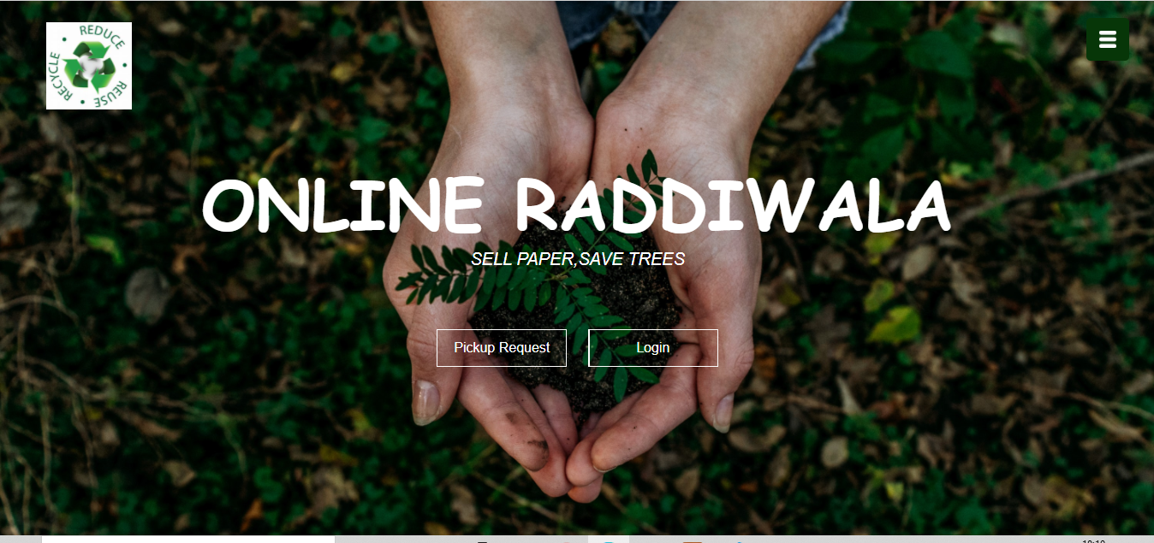

* 1. **USERLOGIN**

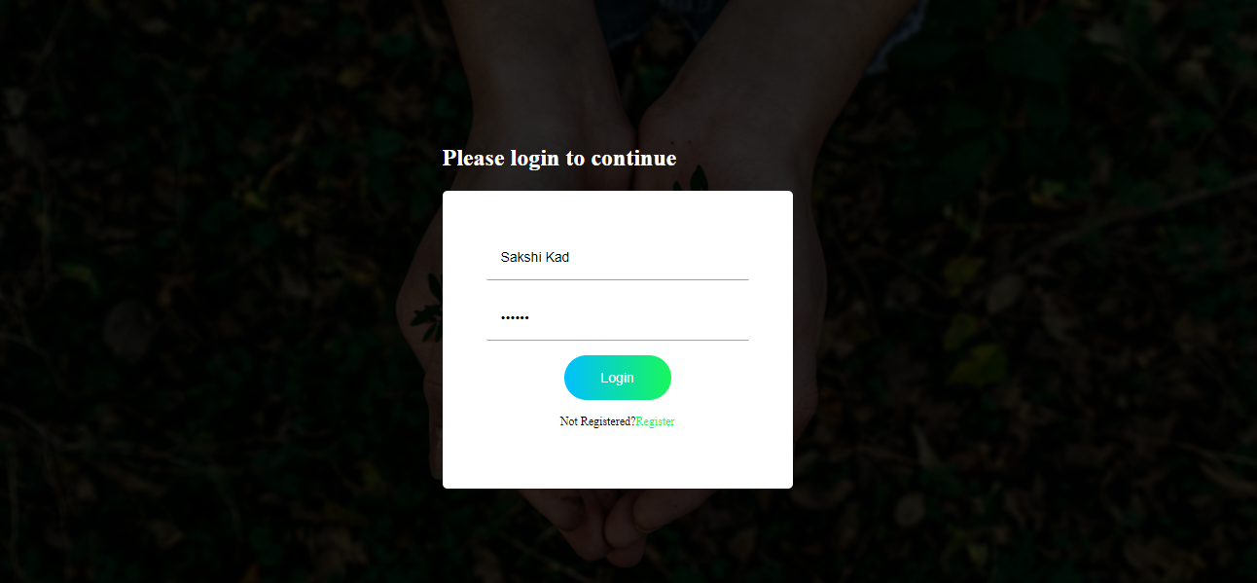

**Login Result**

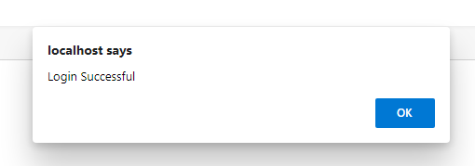

* 1. **USER RESISTRATION**

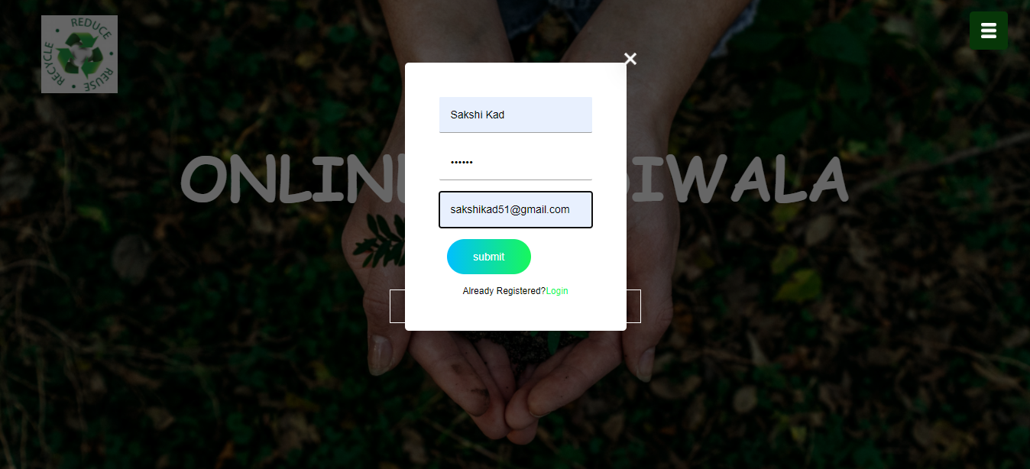

**REGISTRATION RESULT**

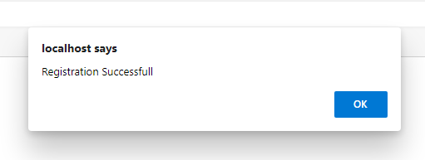

* 1. **PICKUP REQUEST**

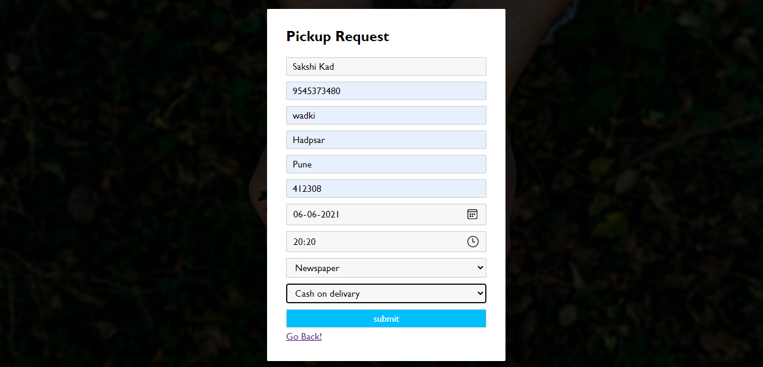

**PICKUP REQUEST RESULT**

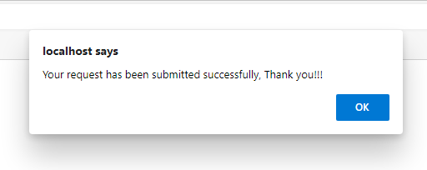

* 1. **USER PROFILE**

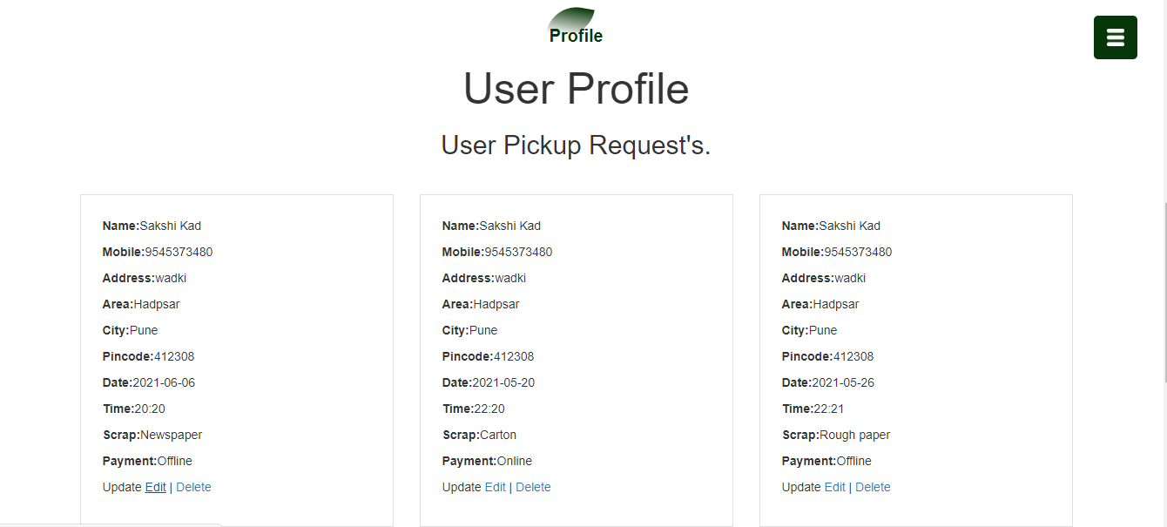

* 1. **USER FEEDBACK**

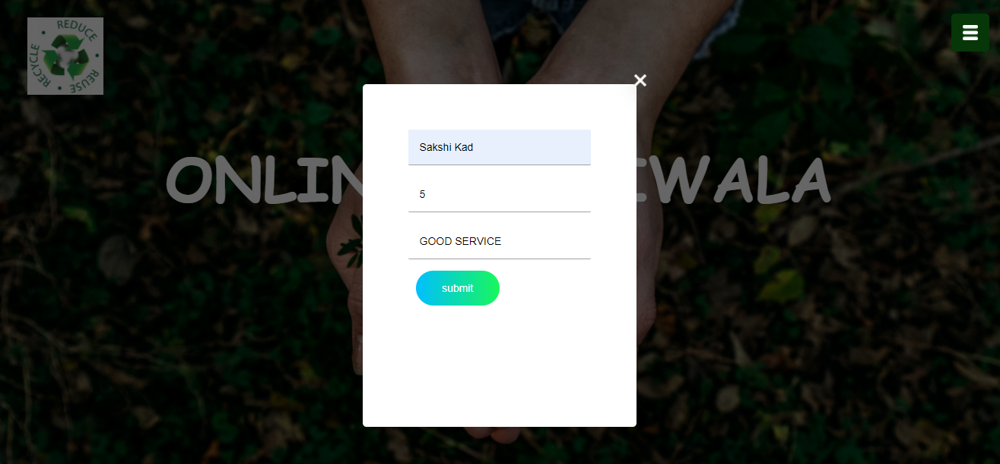

**FEEDBACK RESULT**

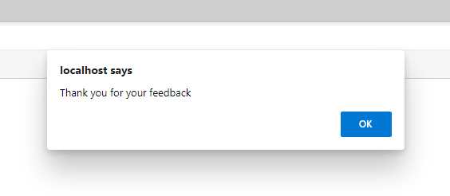

* 1. **SERVICES**

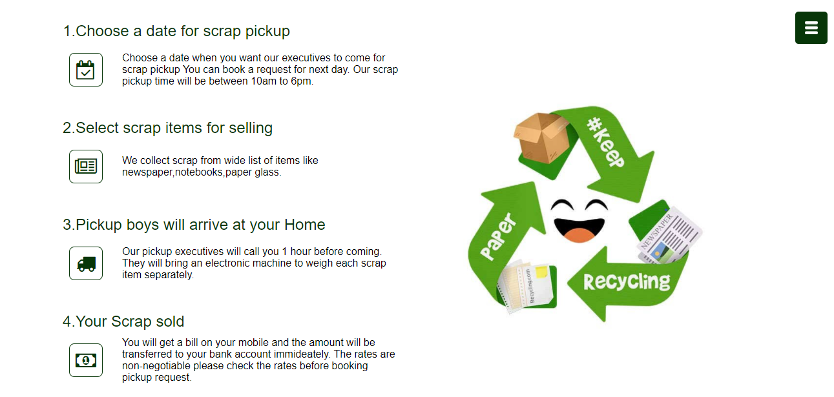

* 1. **RATE CARD**

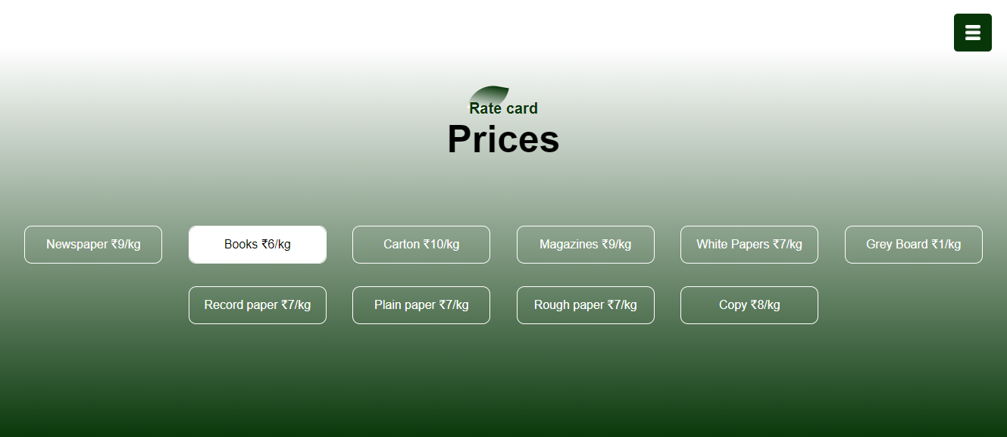

**CHAPTER 4:**

**IMPLEMENTATION**

**AND**

**TESTING**

**4.1. TESTING AND DEBUGGING**

1. **FUNCTIONAL TESTING**

* User is able to login if entered login details are correct otherwise system gives invalid message.
* User is able to send and delete the pickup request successfully
* User can update profile
* User can give their feedback message.

1. **NEVIGATION TESTING**

* All the links on webpage are at appropriate location and no any link is broken
* All the command buttons are working properly and redirecting to correct page
* Smooth flow is maintained through out website

1. **USEABILITY TESTING**

* Mandatory data entry fields are given with placeholder / suggestion to fill those forms.
* Related information is grouped together on webpage for user’s better understanding and knowledge about the process.
* Web pages are loading fastly.

1. **SECURITY TESTING**

* In appropriate input data received from user which is out of bound is not accepted.
* Password is in encrypted format
* System does not allow invalid or unregister user.

**CHAPTER 5:**

**RESULT AND CONCLUSION**

* 1. **ADVANTAGES AND DISADVANTAGES**

**A] ADVANTAGES**

* It is fast, cost efficient and reliable.
* Data redundancy and inconsistency.
* Very user-friendly.
* Easy accessibility of data.

**B] DISADVANTAGES**

* Rise In Competition.
* No Personal Shopper Assistant.
* Lack Customer Loyalty.
* Delay in Pickup.
  1. **LIMITATIONS**
* Due to time limit the survey was restricted.
* Payment can’t possible before paper waste collection.
  1. **CONCLUSION**

Objective of this project was to satisfy user’s requirement successfully implementation of this system design user friendly and easy operating system. Good communication and relation between waste collector and society can be established with the help of technology. Problem regarding proper disposal management and lack of society- management coordination are eliminated by application of technological skills in web development.

* 1. **FUTURE ENHANCEMENT**
* OTP Generation for security purpose
* Send text message after accepting or deleting pickup request.

**REFERENCES**

* https://www.codeinwp.com/blog/introduction-to-parcel-js/
* https://www.w3schools.com/bootstrap/bootstrap_grid_basic.asp
* <http://www.images.google.com>
* <http://www.slideshare.net>